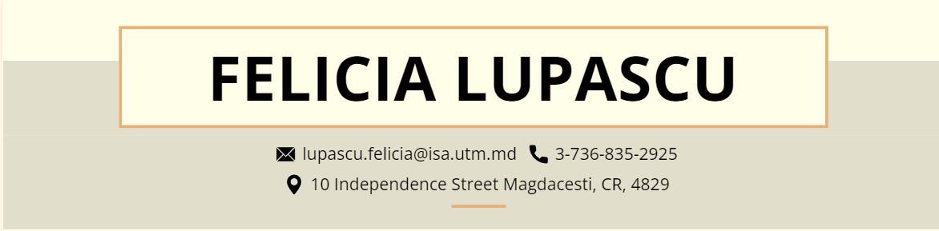

**Mrs. James Lean**

**NVIDIA**

*Dear, Mrs. Lean*

*I really appreciate providing me with the chance to apply for the position of Software Engineer at your organization. After reading your job description, it's evident that you're searching for someone who is well familiar with the role's tasks and can confidently carry them out. Given these criteria, I am certain that I possess the requisite abilities to competently complete the task and exceed expectations.*

*I am a goal-oriented student now enrolled at Technical University of Moldova (Bachelor of Science in Software Engineering). My instructors and classmates have continuously recognized me as a diligent worker throughout my academic career. I've established demonstrated analytical, problem-solving, and research abilities while working on academic and extracurricular projects, which I aim to use to the Software Engineer position at your organization.*

*After examining my résumé, I am certain that you will agree that I am the kind of qualified and competitive applicant you want.*

*I'm excited to discuss how my specialized talents and abilities will assist your company. Please contact me at 3-736-835-2925 or lupascu.felicia@isa.utm.md to schedule a time that is convenient for both of us.*

*Thank you for your time and attention; I hope to hear from you soon.*